Project Log Book

Group Members:
Software Requirements Specification
for
Quiz Managment System

Feb 09, 2021
1 | 8991 | Usama bin saleem
2 | 9121 | Razi Siddiqui
3 | 10109 | Muhammad Asghar
4 | 9014 | Muhammad Aaqib
5 | 8552 | Syed Naveed Hasnain

Version | Changes Made | Date
1.0 | First Pass for Review | 2/20/2021
1.2 | Second Pass for Review | 3/05/2021
1.3 | Third Pass for Review | 3/20/2021
1.4 | CRM Review Version | 3/30/2021

Table of Contents
1. Introduction
2. The General Description
3. Specific Requirements
4. Supporting Information
1. Introduction

1.1 Purpose

“Quiz System” is a desktop application which is reachable and usable for every type of users who is registered for the quiz and shall be enrolled in database. Our target audience is students and management of schools or college or universities. This application will provide them all friendly user interface and figures to maintain their studies online easily and efficiently. For a beneficial study and quiz you need good capital and innovative ideas to apply them. Now-a-days peoples want the best of everything at one step so web marketing is one of the reliable and easy ways to gather customer interaction. For website of their own business man hires developer and database designer to complete this task and large amount of money is also required to do this. Our application is the solution for them because through this they don’t need to hire many persons. Both desktop development and database designing is included in it..

1.2 Scope In

Internet in today’s world is the main resource of each and every activity that takes place, The main objective of this project is to conduct online test which will help them to become self paced learners and to make them aware of examination pattern of many competitive exams such as PF, OOP, DS, and various courses .Some of the aim of the project includes:-
1. Help students to go beyond their normal curriculum and learn about various other aspects which are apart from academic education.
2. To provide an examination system where, there is virtually no scope of errors and the results are much faster. And the system is more transparent.
3. To provide an environment where students not only can learn but also analyse their performance simultaneously..
The objectives of this development effort are:
- To provide an avenue for students to get their quiz in a more convenient way.
- To implement a prototype of a scaled down version of the final system to test the solution and further develop requirements.
- To increase efficiency of quiz system.
1.3 Scope Out

The following features will not be the part of this Project:

1.3 Definitions, Acronyms, and Abbreviations.

PP - Project Plan
SDD - Software Design Description
SRS - Software Requirement Specification
GUI – Graphical User Interface
PMP – Project Management Professional
UML – Unified Modeling Language

1.4 References

This web application has been prepared on the basis of discussion with Team members and also taken information from following website–www.google.com, www.tcyonline.comand the IEEE website.

1.5 Overview

Chapter 2 of the SRS is a brief description of the characteristics of the software to be built, its functions, its users, its constraints and its dependencies.

Chapter 3 is about specific requirements, such as functional requirements, external interface requirements, performance requirements, and also design constraints and quality characteristics.

Finally, chapter 4 includes all the supporting information, such as the Table of Contents, the Appendices, and the Index.

2. The General Description
The Quiz Management application aims at the Employee assessment programs carried out in the organization by conducting Quizzes. The application focuses on creating a well defined exam/quiz for individual departments. When the authorized examinee attends the exam he gets to view the result on exam submission. The application administrator can view all the results with statistics as the total number of passed and failed candidates and the respective percentages. The application allows creating a scheduled exam / time specific exam.

2.1 Product Perspective
The proposed Quiz Management System is an online Exam System.
The online test created for taking test from students which are enrolled and eligible for test and has following stages
- Login
- Test
- Result

Internal Interfaces:
Database:
- Admin can insert questions
- Admin can schedule exams of specific students
- Admin can access result
- The questions of quiz will be fetched from database
Web Server:
- Provides access to admin to the database
- Authenticates users
- Processes information
- Performs backups
- Produces reports

External Interfaces:

Personal Computers:
- Users:
- Admin
- Students

Figure 2.1 Overview/Architecture Diagram of the quiz system

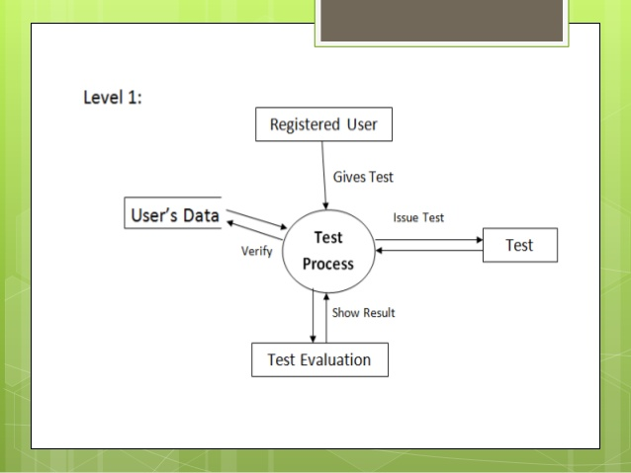

Computer Hardware and Peripheral Equipment to be used:

- Personal Computers (i.e. CPUs, monitors, keyboards, and mice).
- Printers
- Network
- Cell phones

2.2 Product Functions
This section provides a summary of the functions that the software will perform.
2.2.1 Function Relationships
Figure 2.2 to 2.6 depict the relationships among the functions to be implemented by the system.
Figure 2.2 ARRS General Function Relationship/Higher Level Usecase Diagram

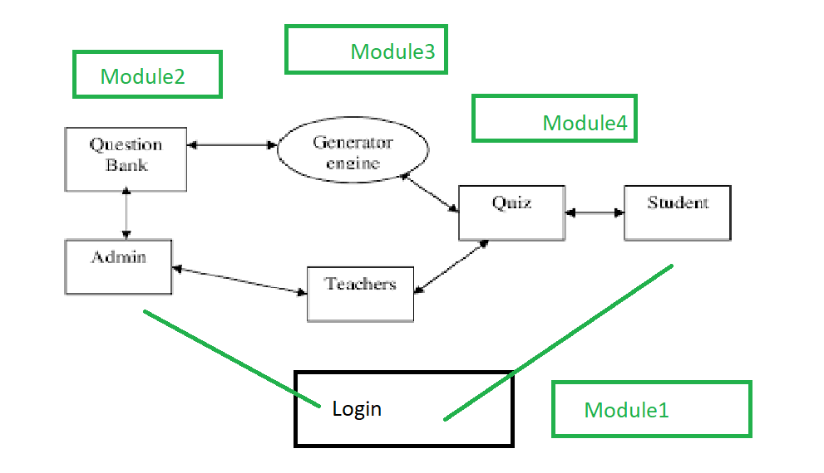

2.2.2 Function Descriptions (Functional Requirement Listings)

2.2.2.1 Log In Function

Description: This function ensures that only authorized students gain access to the quiz system databases. An authorized student is a user who has an account on the system. Users include only students of a institude. The user must type a valid username and password to gain access.

2.2.2 Module 1: quiz panel

Description: This function allows the user to [Make | Drop | View | Update] a question for a particular quiz on a particular date for a certain number of options.

2.2.3 Module 2: schedule

Description: This function allows users to see their schedule of a quiz Admin can update, delete the information of schedule

2.2.4 Module 3: offering a course

Description: This function allows users to see the course. Admin can update, delete the Course to make a quiz.

2.2.5 Module 4: get answers

Description: This function allows users to give their answer. User can update, delete the answers.

2.2.6 Module 5: display result

Description: This function allows users to see their results. Admin can update, delete the result.

2.3 User Characteristics

1. Students
The student is the one that takes the test using the improvement client interface .multiples student
can connect to the application or software and take the test. It is more easily to take the test by student.
2. Admin
The teacher is the one that use this application and software as an editor to create a database
of question of each course and also define a test option it is convenient to think that every teacher
represent user that uses the database editor to make test

2.4 General Constraints

The constraints for the project are:
- The global schema, fragmentation schema, allocation schema.
- SQL commands for above queries/applications.
- How the response for application 1 and 2 will be generated. Assuming these are global queries. Explain how various fragments will be combined to do so.
Implement the database at least using a centralized database management system.

2.5 Assumptions and Dependencies or Business Logic

Proper working of this app is dependent on the internet connectivity of the users’ computer Assumptions and dependencies:
-
It is assumed that the user has basic knowledge of the system (i.e. he/she is not a first time user) as any action by the user is considered valid during an examination.
-
It is assumed that the data entered by the user while registering is true.
Quiz’s question can be made up to one month before a particular quiz.
Network connection will always remain established.
- System will user friendly
• System will active 24 hours in a day
- System will complete on time.

<ADD OOAD REPORT DIAGRAMS HERE>

3. Specific Requirements

This section of the SRS contains design requirements for the Quiz System.

3.1 Functional Requirements

3.1.1 Log In Function

- Description: This function ensures that only authorized users gain access to the quiz system databases. An authorized user is a student who has an account on the system. Users include students The user must type a valid username and password to gain access.

- Usage Scenario/ Use case Description/ Specification:

Description | Allows access to online ARRS
Inputs | Username, password
Source | - User inputs username and password  - Press Login Button

Alternate case
Outputs | Successful login; unsuccessful login
Destination | None
Precondition | Authorized User
Post Condition | No change to students Accounts Database
Side Effects | Only successful logins are sent to quiz system Database

- Detailed Use case Diagram for Login: optional
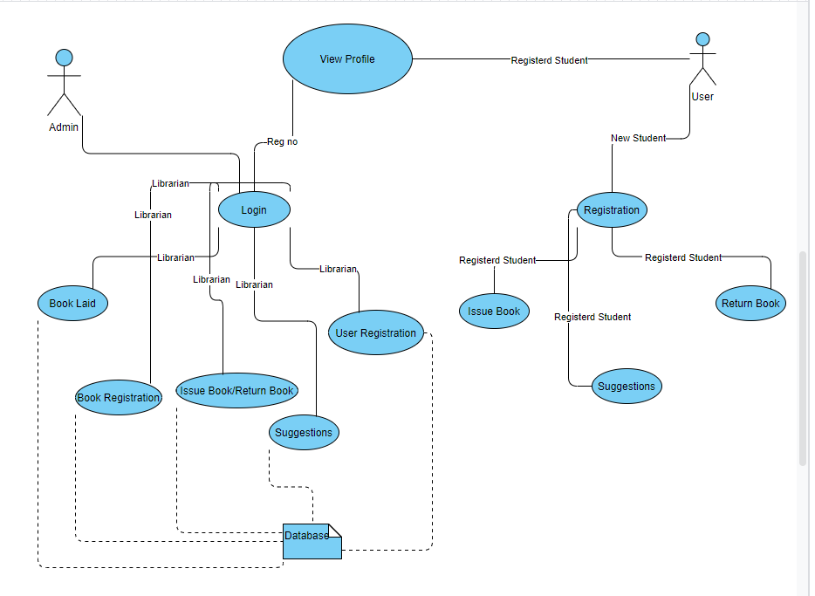

- Use case Realization for Login: optional
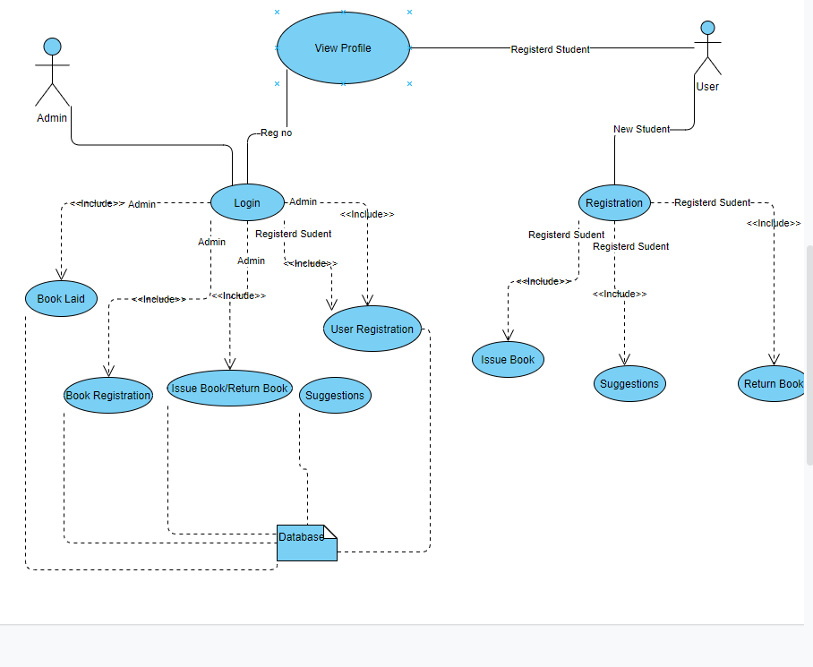

- Flow of Event or Data Flow Diagram for Login: optional
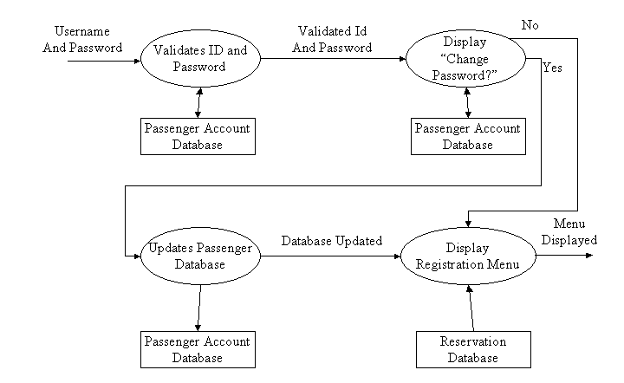

- Sequence Diagram for Login: optional
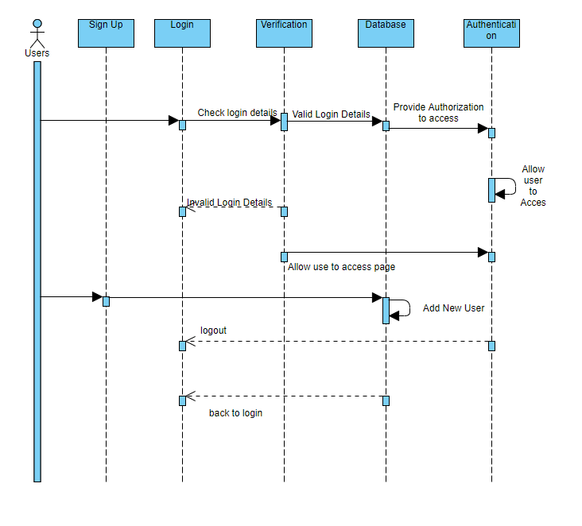

- Collaboration Diagram for Login: optional
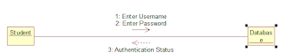

- Activity Diagram for Login: optional

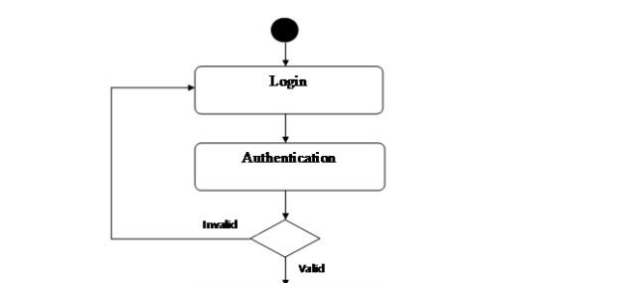
- Class Diagram for Login: optional
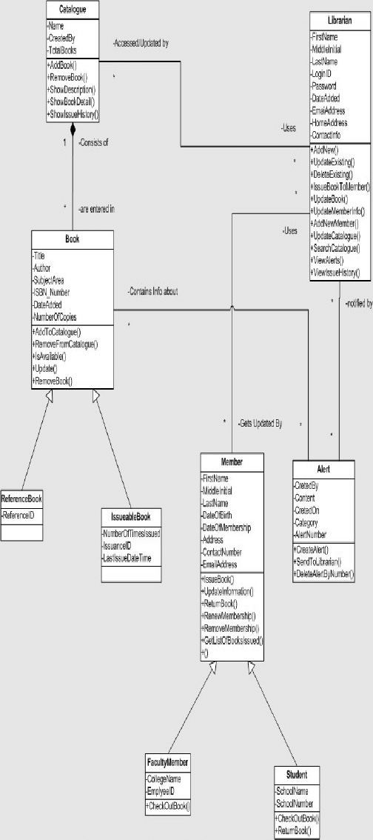

- State Chart Diagram for Login: optional
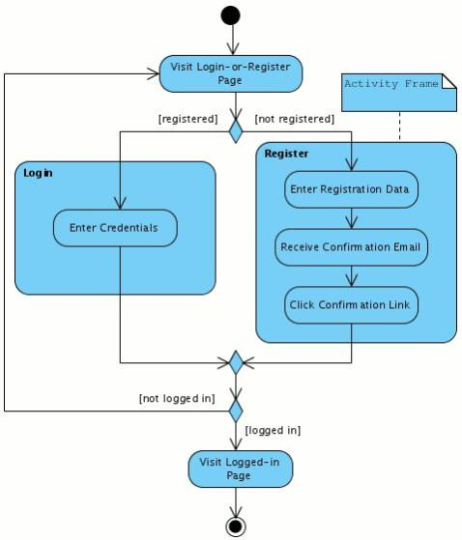

    - Module 1 complete CRUD: Add a question

- Description: This function allows the user to [make | drop | view | update] a question for a particular quiz on a particular date for a certain number of options. Also delete a question and update too.

- Usage Scenario/ Use case Description/ Specification:

Description | [ make | drop | view | update] a Add Question
Inputs | Id , question , option ,correct answer
Source | - Admin inputs id , question , option and correct answer  - Press Button …

Alternate Case
Outputs | Added | Deleted | Viewed | Modified question
Destination | Computer screen  quiz database
Precondition | Valid information; user does not have another two quiz at the same time
Post Condition | N/A
Side Effects | N/A

- Use case Diagram:

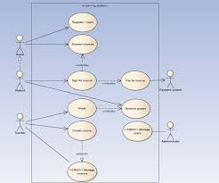
- Use case Realization:

- Flow of Event or Data Flow Diagram:

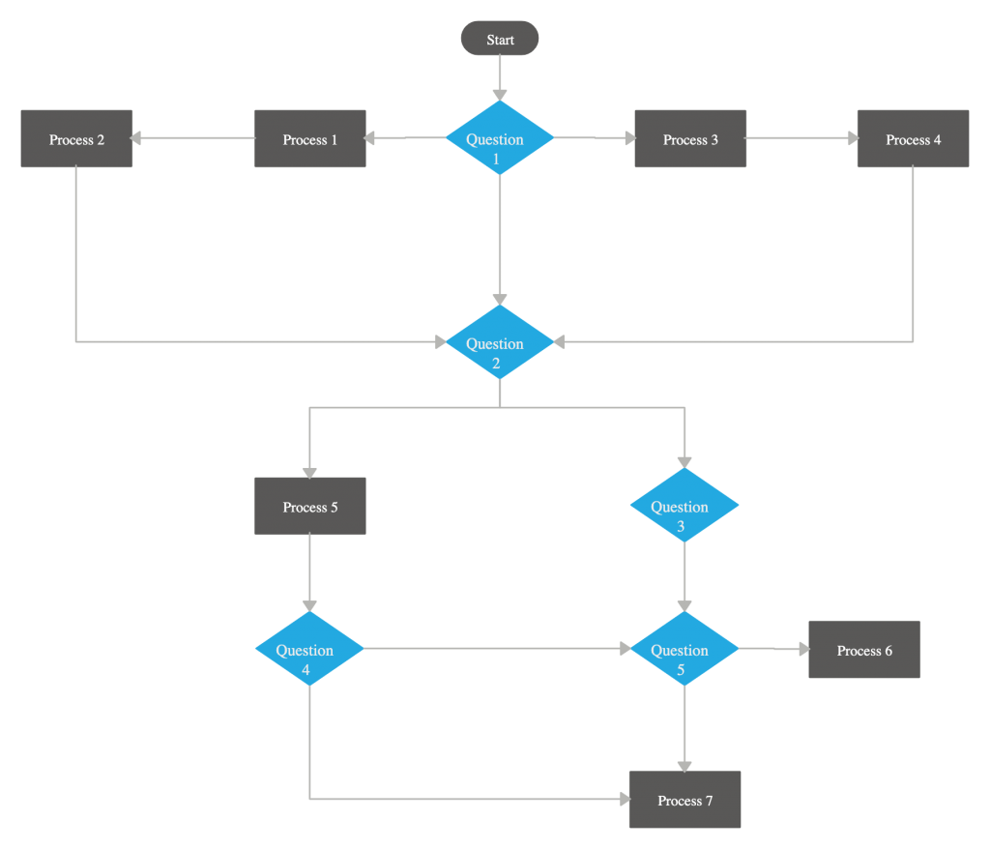

- Sequence Diagram:
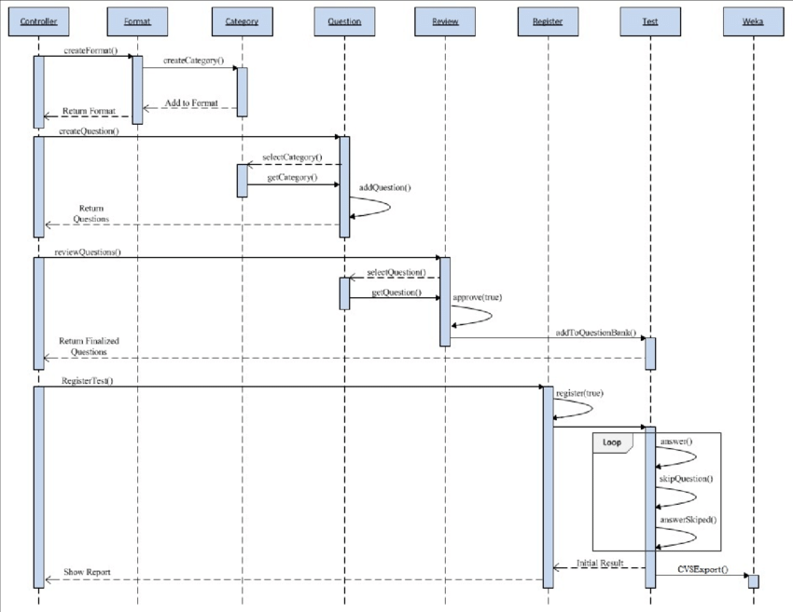
- Collaboration Diagram:

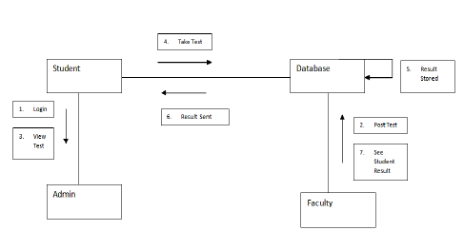
- Activity Diagram:

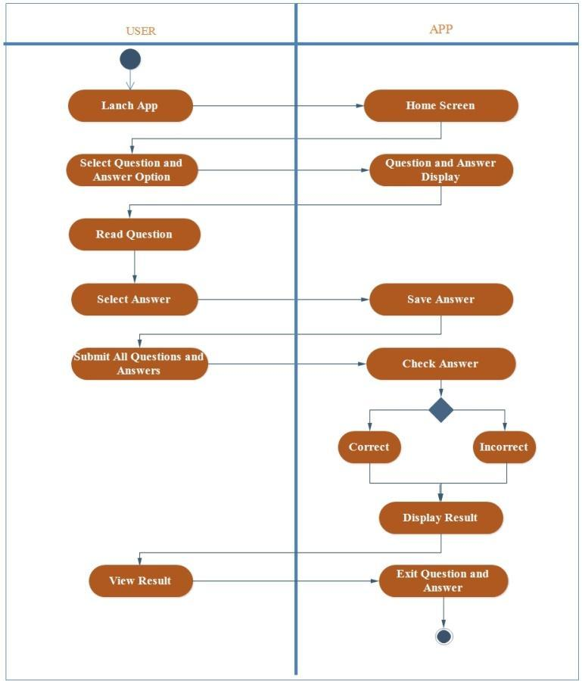
- Class Diagram:
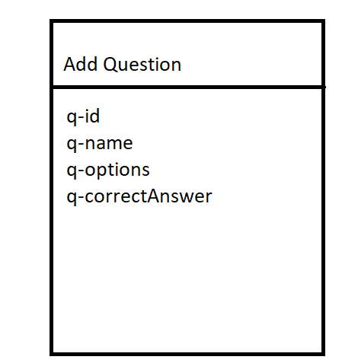

- State Chart Diagram:
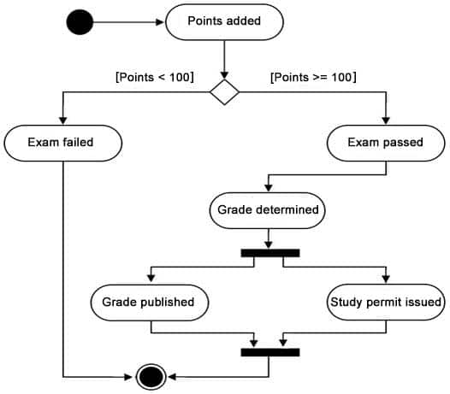

3.1.3 Module 3 complete CRUD schedule

3.1.4 Module 4 complete CRUD get answer
3.1.5 Module 5 complete CRUD Display report

3.2. External Interface Requirements
3.2.1 User Interfaces

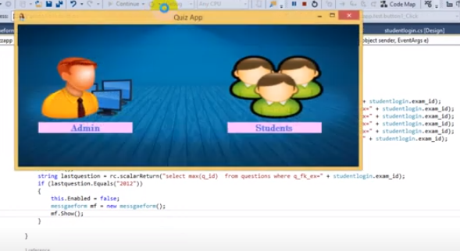
If the user is admin so he will choose admin panel .
If the user is student so he will choose student panel.

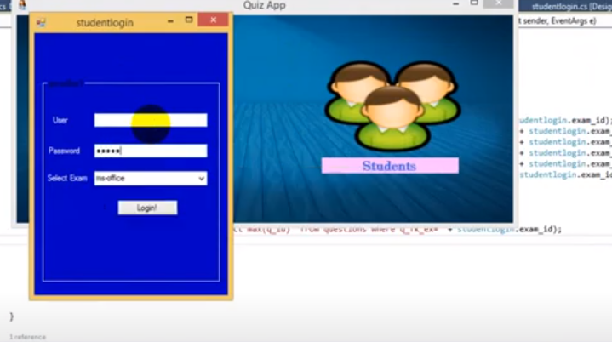

If the user or student is providing accurate Username and password which is registered in our database so our system will login him otherwise it will through an error of invalid user

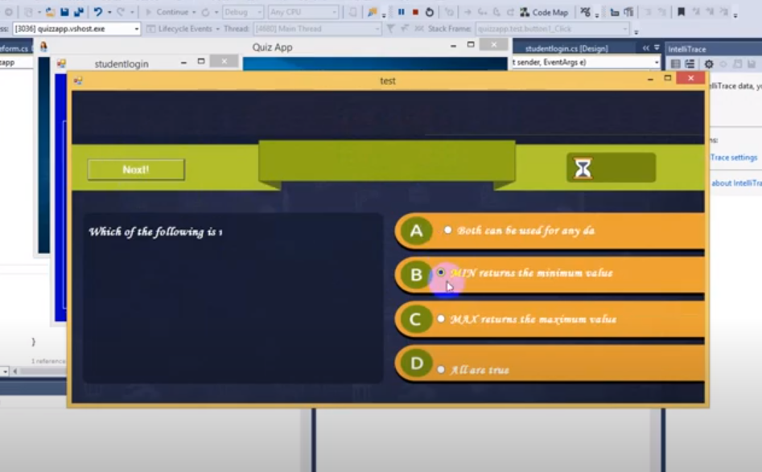

If the user or student is providing accurate Username and password which is registered in our
database so our system will login him otherwise it will through an error of invalid user
Student will choose only one choice from 4 choices on the screen.
he can not go to the next question until he select an option.
after selecting and pressing 'NEXT' next question will appear on the screen.

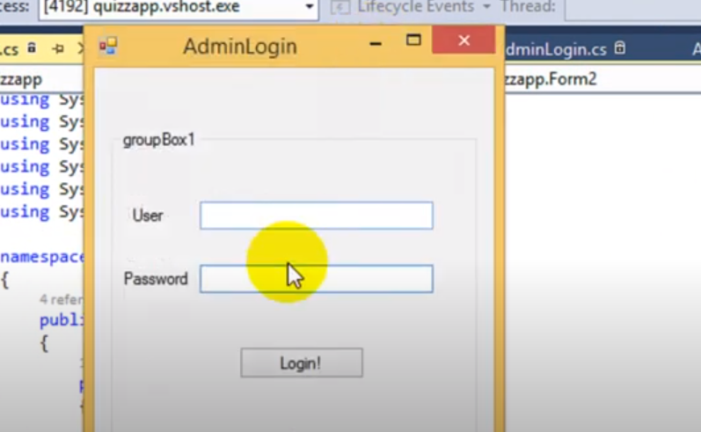

Admin will provide his ID and Password. if it is accurate and registered in the database so our quiz system will give him all the admin rights

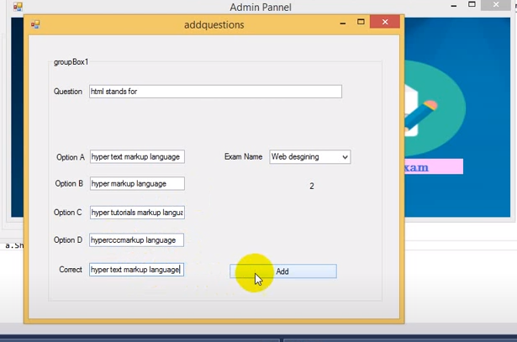

when admin is signed in so he can add more questions by providing a question along with 4 options and a correct answer

3.2.2 Hardware Interfaces
The QMS includes two major hardware components: cellular phones and regular PC's. The cell phones require WAP (wireless application protocol) network protocol, which is already programmed in the latest phones.
The second component involves the regular PC’s, which communicate with the server. The server then communicates with the database. The protocol involved between the PC's and the server is the HTTP protocol, which allows communication between the PC's and the Server. The remote PC's, such as someone accessing the ARRS from home using the Internet, are able access the information through the CGI. The requests come in through the HTTP protocol, and using an ODBC the database results are returned and processed using Perl to give an HTML web page. The format of the output is displayed as web pages.

3.2.3 Software Interfaces
Information about the products used for the ARRS:

OPERATING SYSTEM | WINDOWS OR LINUX
PROGRAMMING LANGUAGE | C# WINDOWS FORM
DATABASE | SQL SERVER
TOOL | VISUAL STUDIO 2013

3.3 Performance Requirements
The following sections list the performance requirements for the system.

3.3.1 User Requirements

User Requirements | Description of Requirement For Design Environment
Location(s) and Number(s) of Users | Guangzhou, Nanjing, Shanghai
Expected Growth in Number of Users
After 1 Year | 50%
After 2 Years | TBD
After 3 Years | TBD
User Expectation
Interactivity | User expect that it provides a very easy to use graphical user interface
Reliability | For some applications, reliability must be 100% during the application session
Adaptability | Network must adapt to user additions, deletions and changes
Security | Encryption software would be used for Credit Card transactions
Cost / Funding | Less than $250K

3.3.2 Application Requirements

Since no specified service is indicated, then we have listed the applications as best – efforts. This may change as we learn more about the application.

The communication package is determined to be bursty in nature, with small data sizes and frequent transmissions. We can consider this application to be interactive-burst, while the database transaction-processing application is described by the CRM as transferring large amounts of data (initial estimates are 1 MB/transaction), we have listed this application as interactive-bulk.

Categorizing  Applications | Best-Efforts | Application  Locations
Communication | 100 Kb/s | Guangzhou and Nanjing
Database Access | 400 Kb/s | All Locations
Database Transaction processing | 1.5 Mb/s | All Locations

3.3.3 Host Requirements

 | Type of Host or  Equipment | Numbers and  Locations
Host A | PC | Guangzhou (10), Nanjing(7), Shanghai(10)
Host B | Database Server | Shanghai
Host C | Application Server | Nanjing

3.4.1 Standards Compliance
There are no design constraints that can be imposed by other standards limitations.

3.4.2 Software Limitations
• must be able to run Internet Explorer or Netscape Communicator web browsers to access the system.
• must have cell-phone web based capability to access the system from a mobile phone.

3.4.3 Hardware Limitations
• Input/Output: One or two-button mouse, keyboard, cell-phone, or touch screen required.
• Network card required at thin-client terminals to make communication with server possible.

3.5 Quality Characteristics
There are a number of quality characteristics that apply to the QMS software system.

3.5.1 Portability
The QMS system will be developed using HTML and Java so that it can be accessed from any type of system using just a regular web browser. It will also be available to users that have web access on their cellular phones. The system will be tested on all types of hardware before being released to ensure that is it compliant with this requirement.

3.5.2 Reliability

The system should be capable of processing a given number of reservations within a give time frame with no errors and the system should be available and operational all the time. During the development of the prototype for the 3 cities, the system will be tested in its actual environment to ensure that it can handle the load of reservations that occur during a regular workday.

    - Usability

- The QMS shall incorporate an integrated database continuous availability layer.
- It shall use software for taking quiz and keeping records in database.
3.5.4 Correctness
The ARRS system will be considered correct when the CRM approves the prototype presented and agrees that all the functions they require are implemented as stated in the Software Requirements Specification.
    - Flexibility

The basic requirements that QMS must fulfill is to create a system that will be online 24x7 365 days, that can be elaborated as student and admin should consider all their studies and all the concerned records anytime they require.

3.5.6 Security

As the QMS will be maintaining all the confidential records of all the students, security should be the first priority that QMS offers to its students. Once the system gains confidence of the students that it is capable of ensuring a quality data encryption to their data and statistics, and privacy terms are simple enough to be understood then security will also be a plus point for QMS.

3.5.7 Maintainability

- The QMS shall permit the swapping and upgrade of hardware without down time.
- The average time to fix shall not exceed one person day.
- The QMS shall permit the upgrade of software without down time.

3.6 Other Requirements
Certain requirements may, due to the nature of the software, the user organization, etc., be placed in separate categories such as those below.

3.6.1 Data Base

The Quiz Management System will have two main databases. One is the Quiz Database, and another is the student Database. These database will be created with MYSQL server. The following are the requirements for these databases that are to be developed as part of the product. They include:

3.6.2 Operations
The normal operations required by the user can be viewed as the following:
User-initiated Operations:
These operations include the login operation, which is initiated by the users. Also, the process of becoming a new user is in this category. Building, changing, and viewing itineraries, attempt the quiz and see their results.
Interactive Operations and Unattended Operations:
The users initiate all the operations mentioned above, and almost all of them are somehow interactive. Displaying the QUIZ schedule is non-interactive. The report display is a non-interactive operation, although selecting the desired reports will require user input.
Data Processing Support Functions:
The user account data is used to create new accounts, as well as to validate user id's during login functions. For building itineraries, user input, user account data, and QUIZ schedule data are used, and processed. User data along with final results of user interaction are collected, and used for report generation purposes.
Backup and Recovery Operations:
Both databases used (student account database and quiz database) are production databases. The main operation used for the backup and recovery is MYSQL server. Depending on the customer's needs and budget.
3.6.3 Site Adaptation Requirements
There are no site adaptation requirements for this project.

4. Supporting Information.
There is no supporting information required for this project.

